Page URL - https://rootcabs.com/services
Slug Suggestion - https://rootcabs.com/services
Primary Keyword
Taxi Services in Tamil Nadu
Secondary & LSI Keywords
online taxi booking
affordable taxi service
outstation taxi service
one way taxi service
airport taxi service
local taxi service
car rental with driver
bike taxi service
auto booking service
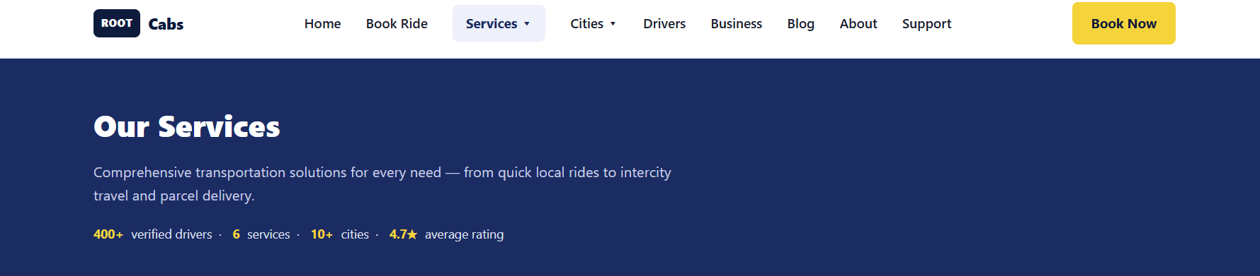

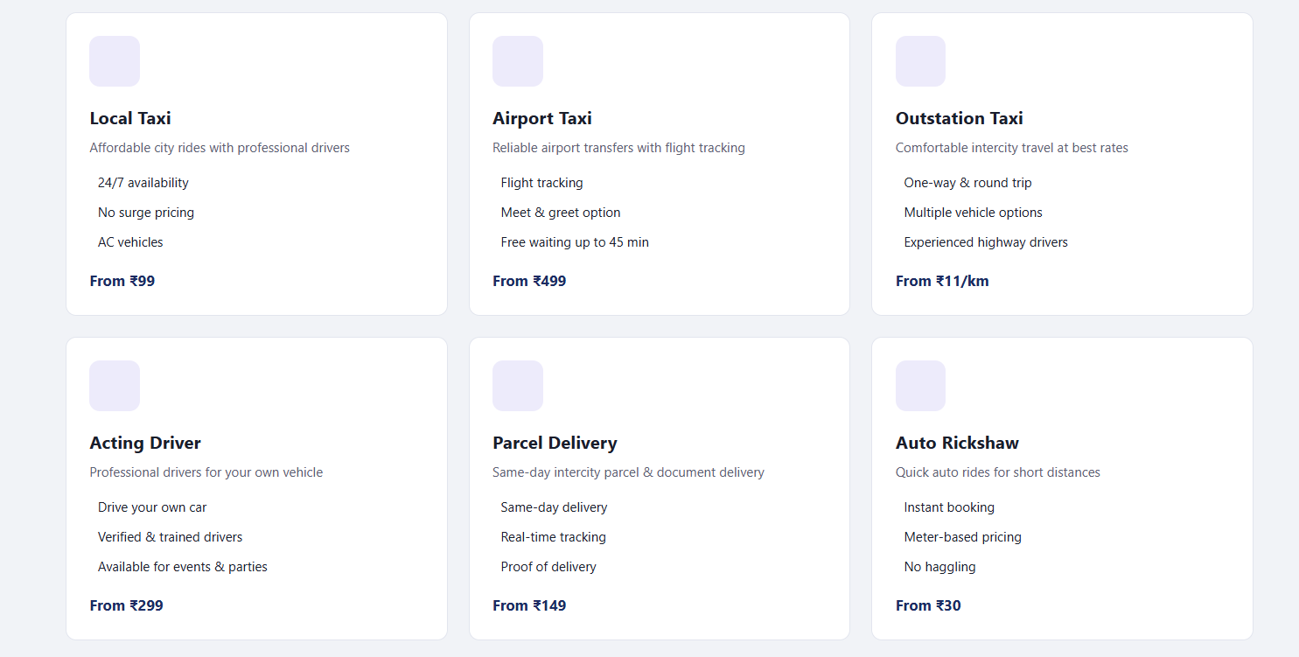

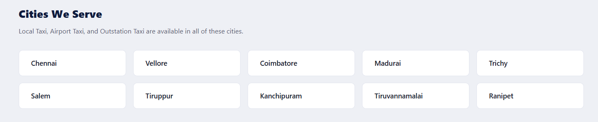

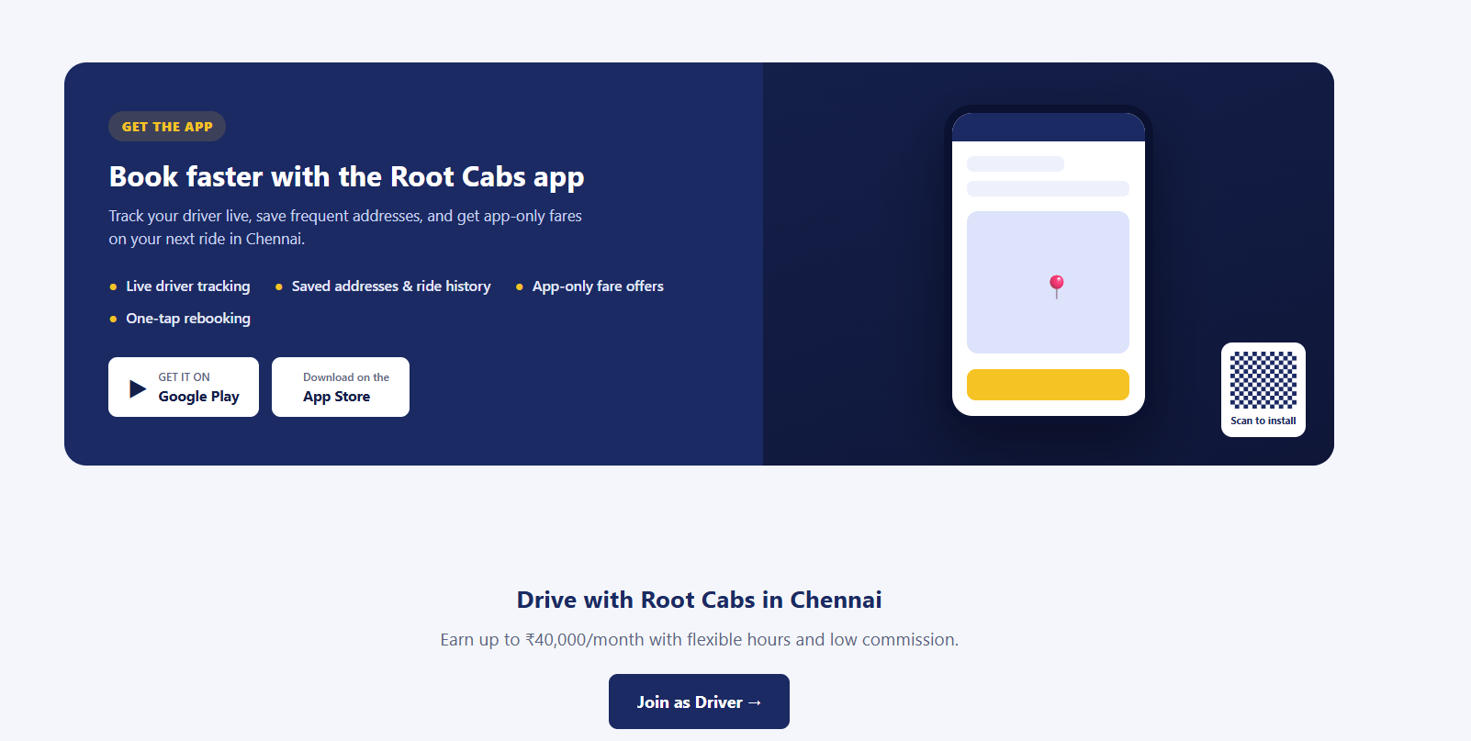

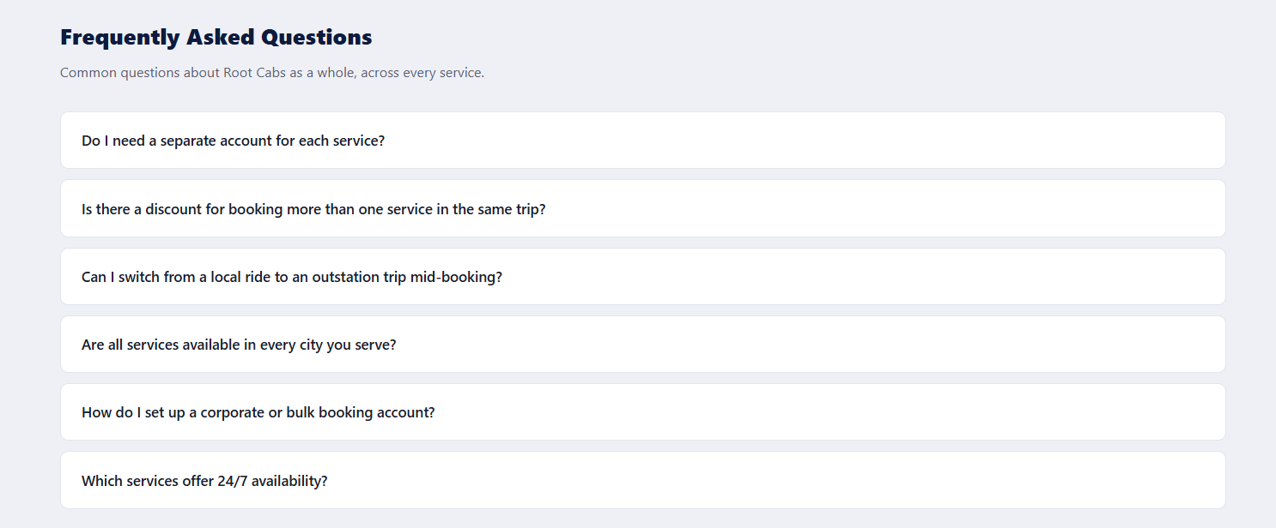

FAQ
Which services offer 24/7 availability?
What payment methods work across all services?
Is there a discount for booking more than one service in the same week?
How do I know which service is right for my trip?
Do I need a separate account for each Root Cabs service?

